Wireless Projector Product Manual
- Product Overview
Wireless screen projector is a revolutionary screen sharing device dedicated to making information display and content collaboration incredibly simple, efficient, and stable. It completely breaks free from the constraints of traditional cables, and with just one click operation, the screen content on devices such as smartphones, tablets, and computers can be projected onto large screen displays such as televisions and projectors in real-time without loss. Whether it's business meetings, team collaboration, classroom teaching, or home entertainment, it's your ideal smart internet partner for achieving "small screen to big screen, creative zero latency".
- operating steps
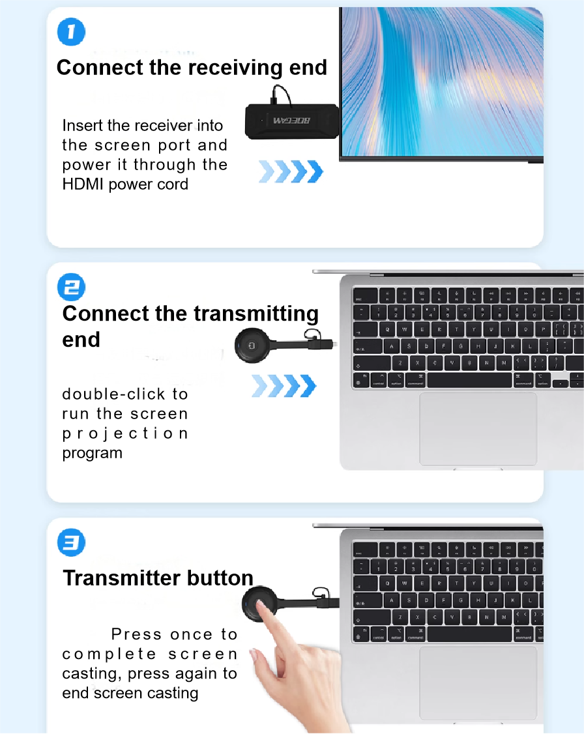
- product model
mirror mode
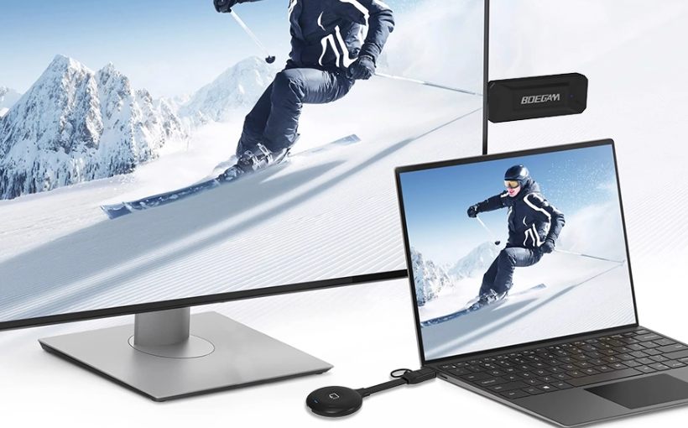
Expansion mode
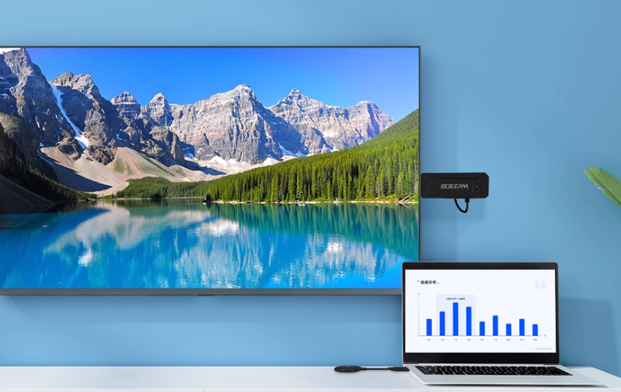
Horizontal and vertical screen switching
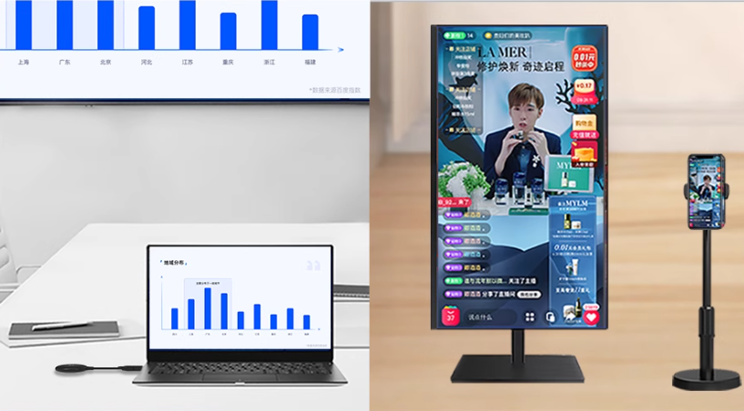
- Product Parameters
class | Parameter Name | description
series | name | BG-4S
operating system | operating system | linux
function | CPU parameter | A71.0GHz Dual-core
hardware interface | Video interface | 1*HDMI 1.4 port
hardware interface | Power interface | 1*5V
video parameter  Sound | Display number of images | Single screen
video parameter  Sound | Set resolution | 1920*108060Hz
video parameter  Sound | Output resolution | 1920x1080P601280x720P601024x768P60
Access performance | Number of connected devices | 16
Access performance | Wireless transmission distance | 20 meters
Access performance | Wireless transmission frequency band | 2.4GHz/5GHz (default 5GHz)
Access performance | Wireless transmission delay | Less than 150ms
Compatibility | support system | Mac,iOS,Windows,Android
Compatibility | Support screen mirroring protocol | Airplay,Miracast,DLNA
Network performance | wireless transmission protocol | IEEE 802.11ac/802.11n,20 channels available
Network performance | Wireless Bridge | support
Network performance | encryption protocol | Supports WPA2-PSK
Network performance | Wi-Fi hot spot | 5G/2.4G Dual-band, default 5G
Network performance | wireless network adapter | Supports 2.4G/5G
Screen mirroring | Screen mirroring method | Any device, including mobile phones, tablets, and computers
Screen mirroring | ejector | USB, HDMI, and Type-C transmitters
Screen mirroring | AirPlay screen resolution | 1080P resolution
Screen mirroring | Miracas screen mirroring resolution | 1080P resolution
Screen mirroring | Airplay pattern | Mirror + Stream
Screen mirroring | Screen mirroring code | support
Screen mirroring | Expand desktop screen mirroring | support
Screen mirroring | Touch feedback control | nonsupport
Screen mirroring | Portrait | support
Screen mirroring | Auto full screen display | support
device management | web set up | support
device management | Number of optional channels | 9(5G)/11(2.4)G
device management | Maintenance status | support
move | Power Supply/Power Consumption | Host: average power consumption does not exceed 4W
move | working temperature | Operation: +5℃~+40℃ Storage: -20℃~+60℃
move | Working humidity | Operating: 0~90% RH, no condensation. Storage: 0~90% RH, no condensation.
- Packing List
